### **Lab Exercise 2- Docker-Compose file**

**Objective:**

Set up a WordPress environment using Docker Compose, including a MySQL database as the backend.

**Prerequisites:**

* Docker and Docker Compose installed on your system.

**Step 1: Create a docker-compose.yml File**

1. In the project directory, create a file named docker-compose.yml.
2. Add the following content to docker-compose.yml:

version: '3.8'

services:

wordpress:

image: wordpress:latest

ports:

- "8080:80"

environment:

WORDPRESS_DB_HOST: db:3306

WORDPRESS_DB_USER: wp_user

WORDPRESS_DB_PASSWORD: wp_pass

WORDPRESS_DB_NAME: wp_database

depends_on:

- db

db:

image: mysql:5.7

environment:

MYSQL_ROOT_PASSWORD: root_password

MYSQL_DATABASE: wp_database

MYSQL_USER: wp_user

MYSQL_PASSWORD: wp_pass

volumes:

- db_data:/var/lib/mysql

volumes:

db_data:

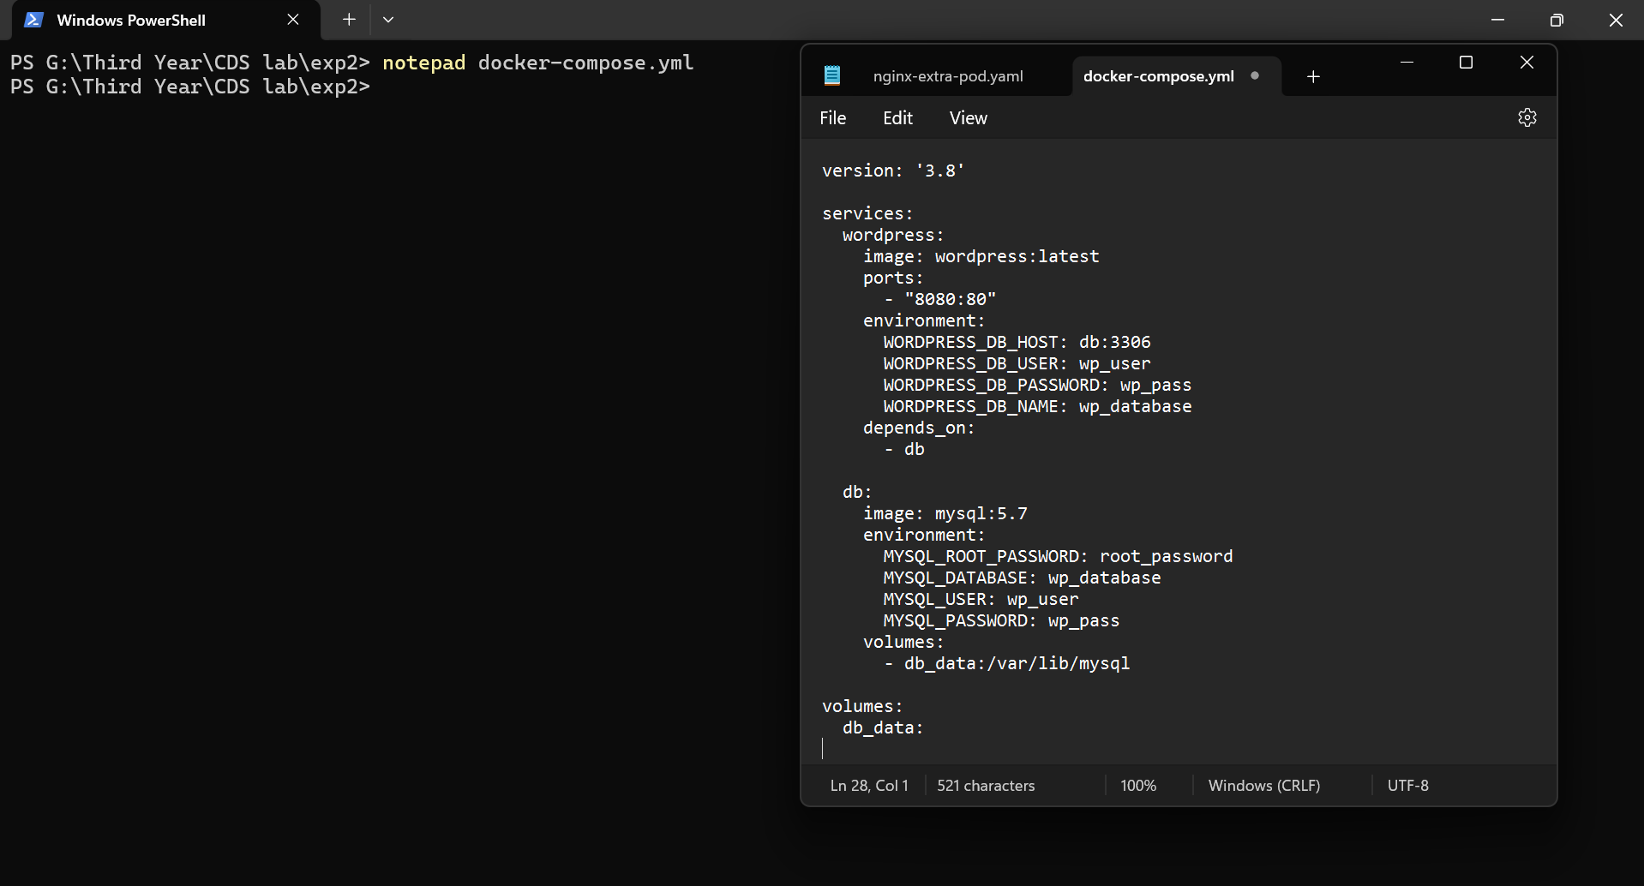

**Step 2: Start the Containers**

1. Run the following command to start the containers:

docker-compose up -d

1. Docker Compose will download the necessary images (WordPress and MySQL) and start both services.

**Step 4: Access WordPress**

1. Open your web browser and go to http://localhost:8080.
2. Follow the WordPress installation steps to set up your site.

**Step 5: Stop and Remove Containers**

To stop the containers and remove the associated resources, run:

docker-compose down

**Explanation of docker-compose.yml:**

* **wordpress**: Sets up the WordPress container, mapping port 80 inside the container to port 8080 on your local machine.
* **db**: Sets up the MySQL container with a volume (db_data) for persistent storage.

**Additional Notes:**

* Modify the environment variables as needed for different configurations.
* To view logs, use docker-compose logs -f.

This setup allows you to quickly start a WordPress site locally and experiment with configurations.